UBND THÀNH PHỐ HỒ CHÍ MINH CỘNG HÒA XÃ HỘI CHỦ NGHĨA VIỆT NAM
TRƯỜNG CAO ĐẲNG KỸ THUẬT Độc lập - Tự do - Hạnh phúc
LÝ TỰ TRỌNG TP. HỒ CHÍ MINH

UNIT 5: How was your vacation?
Reading: You call this a vacation?!

I. OBJECTIVES
By the end of the lesson, the students will be able to:
- Learn some new words about the topic “Vacation”
- Practice guessing the main idea of the reading passage from the title and the illustrations.
- Practice scanning the reading text for specific information.

II. CONTENT
- Vocabulary:
*Irregular verbs:
- drive – drove from … to … (v) – I drove from HCM City to Vung Tau Beach.
- do – did (v)
- make – made (v)

- peak (n) – the pointed top of a mountain, or a mountain with a pointed top
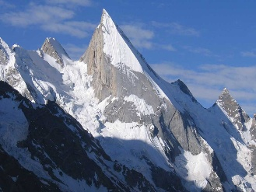

- challenge (n) – a new or difficult task to test people’s skill and ability
- exhausted (adj) – very tired

- raise money for charity (n) – collect money to help people in need
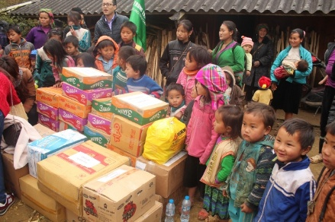

- Reading passage:

My friend Andy called me about three months ago.
“What are you doing in June?” he asked.
“June? That’s months away!” I replied. “ I have no idea.”
“I have a great idea,” he said. “Let’s do the Three
Peaks Challenge. We climb three mountains in 24 hours.”
“Are you asking me to climb a mountain?”
“No, I’m not,” he said. “I’m asking you to climb
three mountains in 24 hours.”
“But why?” I asked.
“To raise money for charity. But don’t worry, they aren’t very big mountains. You climb Ben Nevis in Scotland, Scafell Pike in England, and Snowdon in Wales – all in one day.”
“That’s crazy,” I said. “No way!”
Three months later, Andy and I were in
Scotland, at the top of Ben Nevis. It was
raining, and I was exhausted. I couldn’t
believe we still had two more mountains
to climb. Why did I agree to this?
We drove from Scotland to England and
climbed the next peak. Actually, this one
was OK. It was daytime, warm, and the
mountain wasn’t as high. Then we drove
to Wales to climb the last mountain. This
one was hard. And it was cold again.
But we made it! We did the Three Peaks
Challenge!
I was so happy! I had fun and raised more
than $1,000 for charity. Try it sometime!

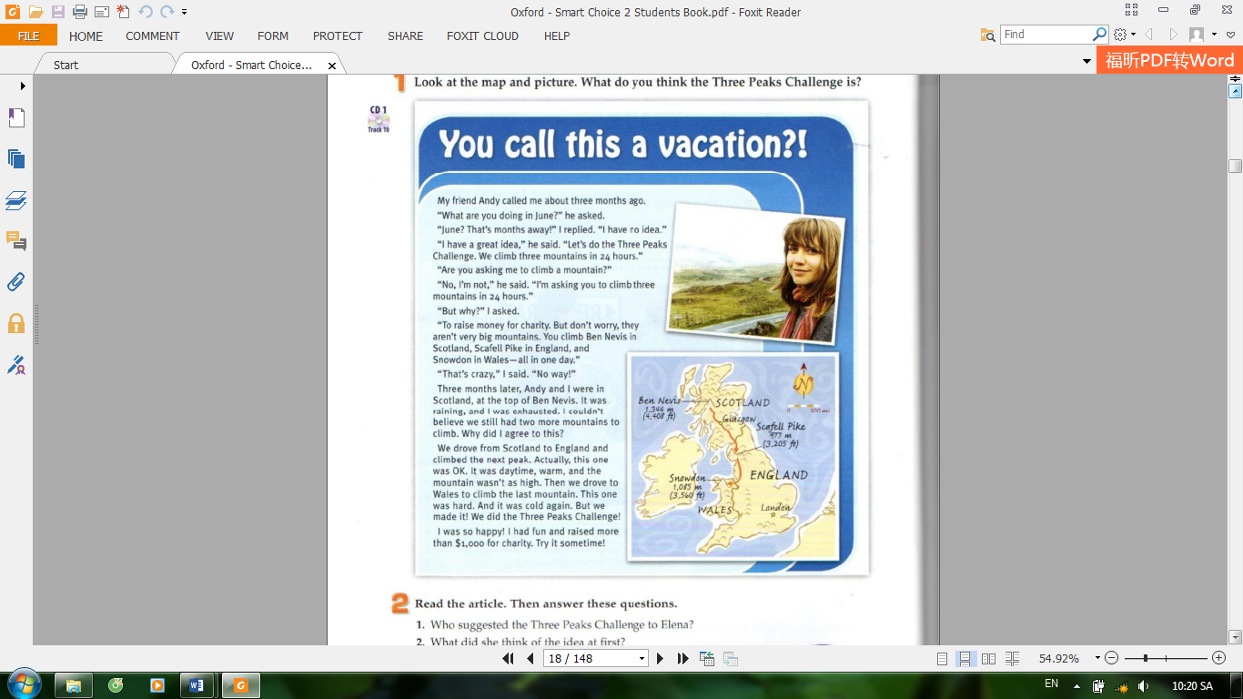

- Reading comprehension questions:

  - Task 1: Guess the main idea (from the title, picture, and map)
Question 1: What can you see in the map?
Suggested answer: 3 parts of the UK: Scotland, England, and Wales;
3 mountains (with height): Ben Nevis, Scafell Pike, and Snowdon

Question 2: What do you think the Three Peaks Challenge is?
Suggested answer: It is a challenge in which people have to climb 3 mountains, i.e. Ben Nevis in Scotland, Scafell Pike in England, and Snowdon in Wales, all in 24 hours.

Question 3: What is the main idea of the reading passage?
Suggested answer: The passage is about Elena’s vacation during which she took part in the Three Peaks Challenge.

  - Task 2: Read and answer the questions:
Question 1: Who suggested the Three Peaks Challenge to Elena?
Suggested answer: Her friend Andy suggested the Three Peaks Challenge to Elena.
Clues: from 1st to 7th lines
My friend Andy called me about three months ago.
“What are you doing in June?” he asked.
“June? That’s months away!” I replied. “ I have no idea.”
“I have a great idea,” he said. “Let’s do the Three
Peaks Challenge. We climb three mountains in 24 hours.”

Question 2: What did she think of the idea at first?
Suggested answer: She thought it’s crazy.
Clues: 16th line
“That’s crazy,” I said. “No way!”

Question 3: How did she feel after climbing the first mountain?
Suggested answer: She was exhausted.
Clues: from 18th – 20th lines
Three months later, Andy and I were in
Scotland, at the top of Ben Nevis. It was
raining, and I was exhausted.

Question 4: How did she feel when she finished the challenge?
Suggested answer: She was very happy.
Clues: 2 last lines
I was so happy! I had fun and raised more
than $1,000 for charity. Try it sometime!

Question 5: How much money did she raise for charity?
Suggested answer: She raised $1000
Clues: 2 last lines
I was so happy! I had fun and raised more
than $1,000 for charity. Try it sometime!

  - Extra exercise: Summarize the journey of the Three Peaks Challenge
Question: Use the following words to fill in the table:
warm England Wales raining Scotland cold
Mountain | Location | Weather
Ben Nevis
Scafell Pike
Snowdon

Suggested answer:
Mountain | Location | Weather
Ben Nevis | Scotland | raining
Scafell Pike | England | warm
Snowdon | Wales | cold

  - Open questions:
Do you like joining in the Three Peaks Challenge?
How do people raise money for charity in Vietnam?

III. REFERENCE:
Wilson, K. (2007). Smart Choice 2. Oxford: Oxford University Press.

